Julie Ellis Peggy Jones Abigail McGreehan Beverly Wedell Lori Wright

Dear Parents:

The Worthington Schools Orchestra Department is announcing the opening of enrollment for string classes for the 2018-2019 school year. As a fifth grader, your child will be able to take part in our beginning strings program. Today, your fifth grader was introduced to the members of the string instrument family during a special assembly. The Worthington schools offer lessons on violin, viola, cello and double bass at no charge. Two 45-minute lessons are given each week, throughout the school year, during the school day. Class times have been mutually agreed upon with the classroom teachers and building principals to best accommodate the student’s weekly schedule. Once your child begins to play a string instrument, he or she will have the opportunity to continue playing throughout their school years in Worthington.

There are countless reasons why a child wants to play an instrument. As parents, we know the value of music study for our child’s development – but the selection of a particular instrument is generally based upon your child’s pre-exposure to musical groups playing the instrument, and the attraction they have to an instrument’s “tonal qualities.” It is particularly important for your child’s continued interest, enthusiasm and dedication to an instrument to allow your child to select the instrument to which they are attracted. To help your child through difficult times when playing abilities are not acquired quickly, the attraction that drew them to the instrument can not be overemphasized.

We ask that you attend one of two informational meetings to meet the teachers, receive further information, and have your child fitted with the proper size instrument prior to visiting the music store. The meeting times and places are below:

Parent Meetings and Instrument Fittings:
Tuesday, May 15 - Thomas Worthington High School Auditorium – 7:00pm
(300 W. Granville Rd., Rt. 161, between High St. and Rt. 315)

Thursday, May 17 – Worthington Kilbourne High School Auditorium – 7:00pm
(1499 Hard Road – across from McCord Middle School)

Saturday, August 11 – WORTHINGTON DAY AT THE LOFT VIOLIN SHOP – 4604 N. High St., Cols.

How to Register for Orchestra:
Visit http://www.worthingtonorchestra.com/elementary.html and click on the “REGISTER HERE!” button at the top of the page. If you need a hard copy of the enrollment form, please ask your classroom teacher or building secretary.

Forms are also available in Spanish.

(over for instrument choices and fittings information)

Instrument Choices: Students may choose the violin, viola, cello, or double bass in 5th grade orchestra (pictured below).

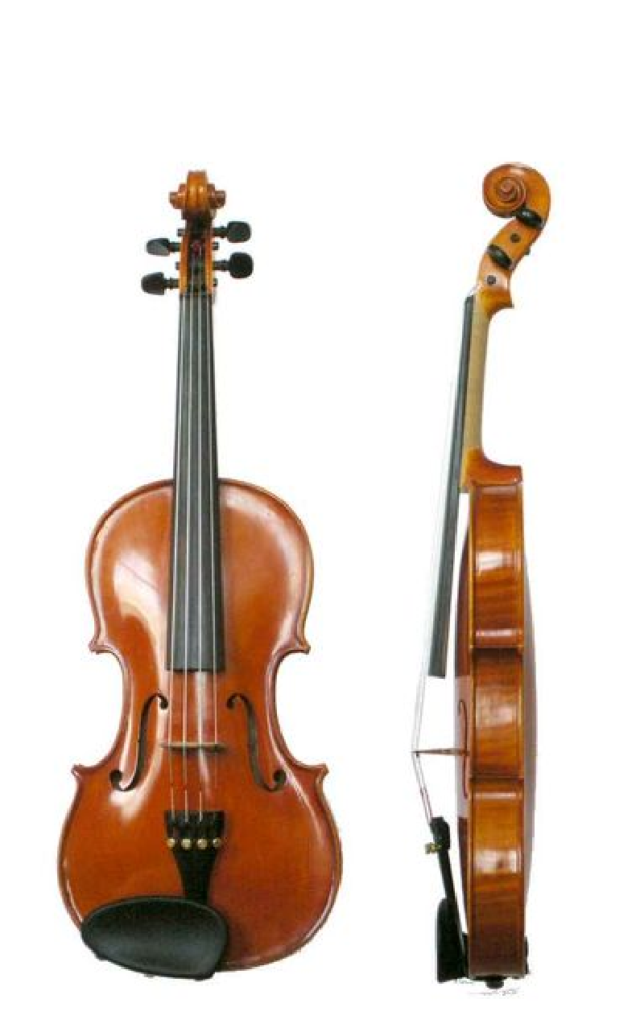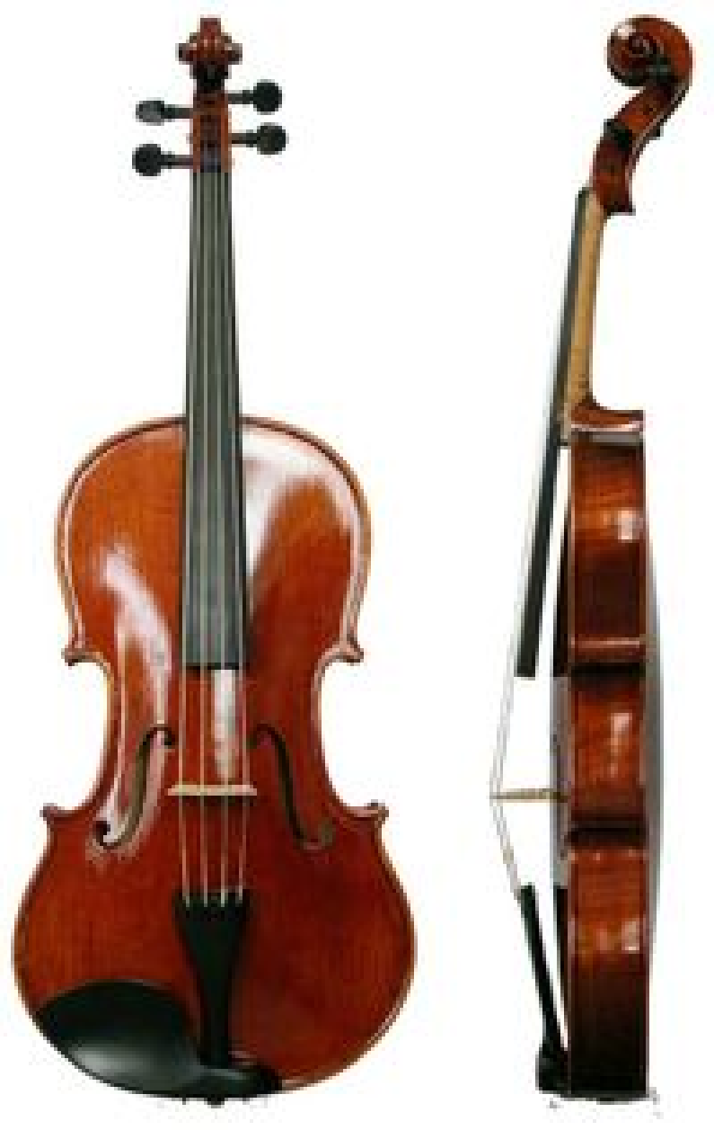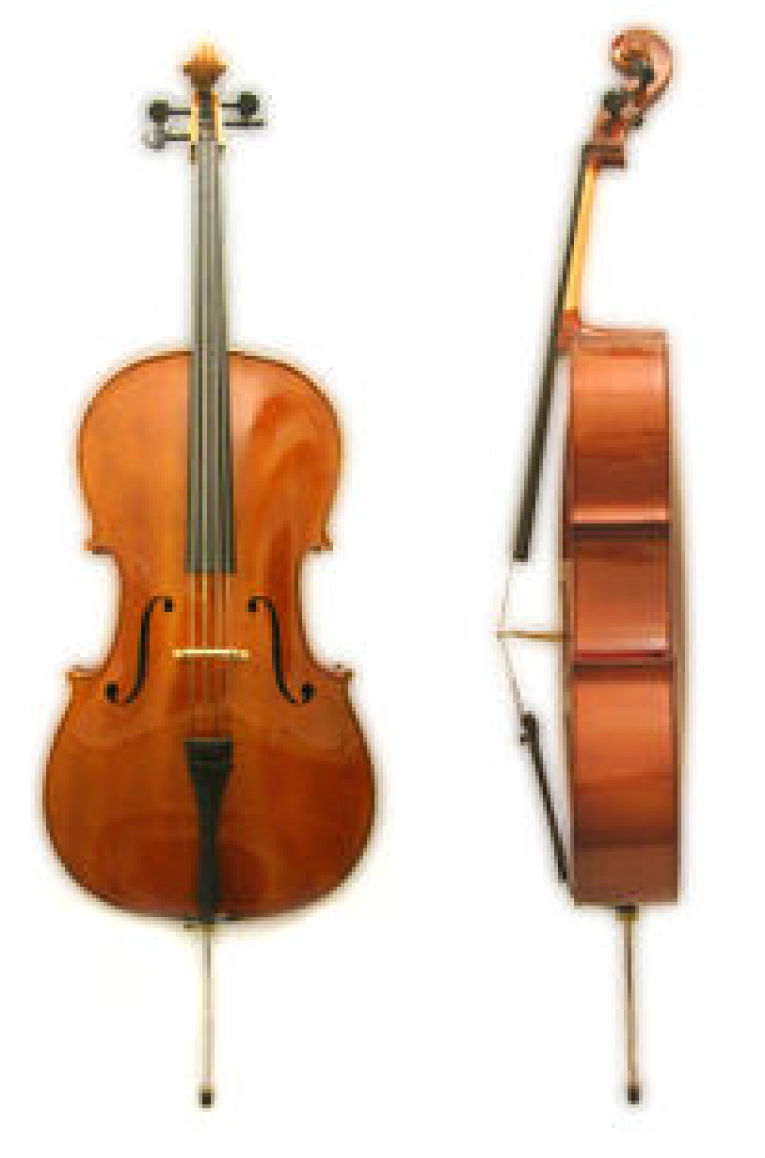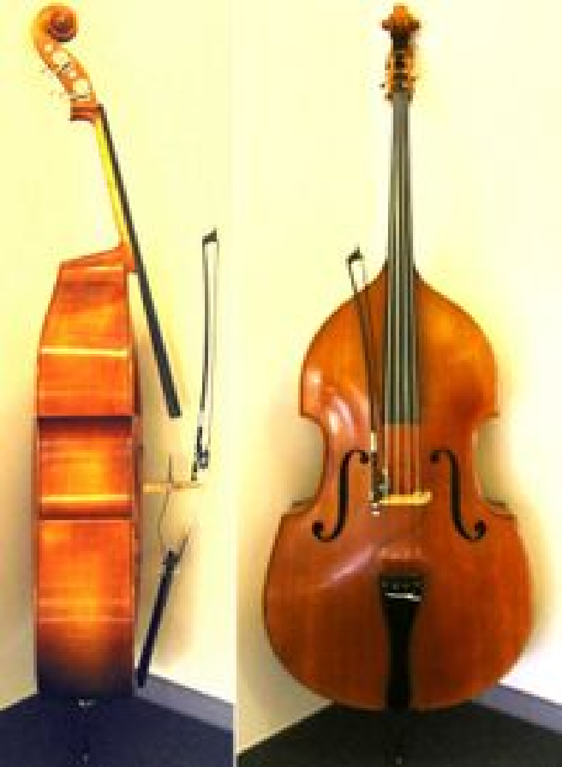
VIOLIN VIOLA CELLO STRING BASS

Instrument Fittings: Beginning violins, violas, cellos, and basses come in a variety of sizes so young students can learn an instrument with ease. As children grow, they can exchange their smaller instrument for the next size up until they reach a "full size" instrument. If your child is interested in playing the double bass, the 3/4 bass is considered full size.

All incoming 5th grade students will be fitted for an instrument that is a proper size for each child to play successfully. These fittings will take place on Tuesday, May 15 and Thursday, May 17 at TWHS. If you are unable to make one of these fittings, a representative from The Loft Violin Shop can fit you at their store.

Cellos and Basses: Worthington Schools owns several cellos and basses. The school program will provide one
for your child at each school so the instrument does not have to be transported back and forth from
home. You still need to rent one for home. Once all the schools have instruments, the extras will be
made available for rent from the school system for $45.00 a year. Selection is done by lottery. If you wish to be included in this lottery, indicate this on your registration form.

Contact information for your teachers:
Julie Ellis - Evening Street - jellis1@wscloud.org
Peggy Jones - Colonial Hills, Granby, Liberty, & Worthington Estates - pjones@wscloud.org
Abigail McGreehan - Wilson Hill - amcgreehan@wscloud.org
Beverly Wedell - Slate Hill, Worthington Park - bwedell@wscloud.org
Lori Wright - Bluffsview, Brookside, Worthington Hills - lwright@wscloud.org

We can't wait to see you in the fall!

